Technology Bucket –Smart Education

Category – Software

Problem statement – Attention Span Detection in Online Instructor Led Sessions

Organization – Great Learning

Team Name – Team Tesseract

Team Leader name – RK Rahul

**Problems Statement**

As per a report by KPMG, it is estimated that by 2021, online education market in India is going to be around $ 2BN. Currently dominating and emerging categories in online education are K12 education, test preparation and professional learning Great Learning is a leading Ed-Tech company based out of India which is helping professionals develop career critical competencies in area of Analytics & Data Science, Machine Learning, Artificial Intelligence, Cyber Security, Cloud Computing, Design Thinking, Digital Marketing and many more. Great Learning has academic collaboration with leading Indian and global institutes like Great Lakes institute of management, Purdue University, UT Austin’s McCombs School of Business, Stanford University and so forth to deliver these programs. Since 6 years of its founding, it has impacted careers of 10,000+ working professionals Great Learning’s online programs are flipped classroom instructor led programs. In flip classroom format, learners are expected to go through video lectures on a weekly basis and then participate in live online instructor led sessions in a micro group containing up to 10 learners. The agenda of instruction led session is to do a quick debrief of video lectures for the week and discuss practical applications of the concepts covered in the video lecture of the week The problem statement is to create a mechanism to monitor and measure the attention span of the learners in the instructor led online sessions. Following are a few ideas on the measures that can be used to quantify the level of attention span: • out of the designated session-time, what proportion of session was one-way dialogue vs two-way dialogue • number of distinct learners who participated in the session • presence of background noise, chatters in the session, etc.. Expected Outcomes • Real time dashboard that quantifies the participation for each participant • Real time triggers in case of sub-optimal participation • Suggestions (along with implementation) of other ideas to quantify level / quality of interactions Great Learning will be sharing sample recording of the online mentored sessions.

**Solution**

The main objective of this application is to monitor the attention level of students in an online seminar and provide real time feedback about attention level to the lecturer and students. This application is developed for the learner i.e. the student to analyse their understanding and improve based on the feedback. This application uses Machine Learning and image processing techniques such as eye tracking, blink rate, facial expression detection using haar cascade classifier, etc. to map the user’s selective attentiveness. Subsequent frames with an interval of 3 seconds will be processed in real time to determine the change in position of the user. This application also uses the microphone in the user’s device to find the noise level in the background, if the noise of the environment is greater than the threshold level the user is in a disturbing environment. Python libraries like port audio can be used to find the ports in which audio is playing. The conversation is a two way dialogue if the audio is sent through the user’s microphone. The total time of two way dialogue is calculated. A real time graph is plotted containing key parameters like blink rate, noise level throughout the session, ratio of two way dialogue to the entire session and attention level of each user will be displayed to the lecturer for further analysis.

**Solution Steps**

1. The video from the user’s webcam is processed and semantic segmentation is applied to subtract the background from the user.
2. Subsequent frames are compared with an interval of 3 seconds and the change in position of user is determined.
3. Blink rate of the user is calculated using the Haar cascade classifier.
4. Eye position of the user is tracked using tools like PyGaze and GazeTracking and is used to detect whether the user is distracted during the seminar. If the user is distracted for more than a particular time, a warning is given and focus mode is turned on. i.e., all contents on the page except the seminar video will be blacked out.
5. The user environment’s sound (in decibels) is measured from the microphone and if it is more than a certain threshold value, it can be concluded that the user’s environment is noisy and can affect his/her attention level.
6. Python libraries like portaudio can be used to monitor the audio ports and detect the port (microphone or speaker) from which the audio signal is coming. This can be used to determine whether the conversation is one way or two way.
7. Using all the above parameters, the attention level of each candidate is calculated and a real time graph is plotted. Average attention level is displayed at the end of the seminar.

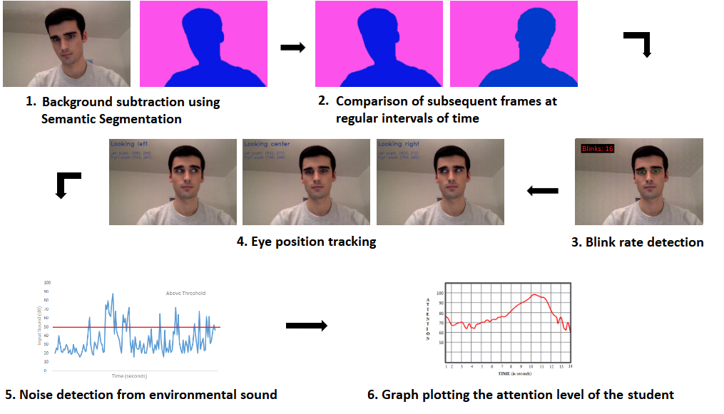

**Value Proposition:**

* Accurate calculation of Attention level of each user in real time.
* Warning, alert given to the users if their attention level is below average.
* Feedback given to the lecturers using Data analytics based on the average attention level of the users.
* Real-time graph plotting the attention level including key parameter.
* Detection of change in position, blink rate detection, eye position tracking, noise level monitoring and two way communication ratio.

**Differentiation:**

* Semantic segmentation is used to separate the user from the background and the changes in user’s position is determined by comparing subsequent frames.
* The eye position of the user is tracked continuously to determine his/her point of view.
* Blink rate is calculated in real time.
* The user’s environmental sound and the noise level is monitored in real time.
* Graphs are plotted for each key parameter in real time.
* A precise and detailed graph is plotted to display the attentiveness of candidate during lecture.

**Core Technologies:**

* **Python** - The project is implemented using Python programming language.
* **OpenCV -** It is an image processing library in C++, Python.
* **Haar cascade classifier -** It is an effective object detection classifier which can be used to detect the number of blinks in real-time from the user’s video feed.
* **Semantic segmentation -** It is an image processing algorithm used to classify each and every pixel in an image into a class and can be used to separate the user from the background.
* **pyGaze -** It is a tool used for eye tracking in python.
* **GazeTracking -** It is another tool used for tracking the position of the eye such as looking left, looking right, looking center, etc.
* **portAudio -** It is an open source compiler library for audio playback and recording.
* **pyAudioanalysis -** It is an open python library that provides a wide range of audio-related functionalities focusing on feature extraction, classification, segmentation and visualization issues.
* **Matplotlib -** It is a plotting library for the Python programming language used for plotting graphs.

**Team details**

|  |  |  |  |  |
| --- | --- | --- | --- | --- |
|  | **Name** | **Gender** | **Email id** | **Mobile number** |
| Team leader | Rahul RK | Male | rahulrk.2303@gmail.com | 8778109200 |
| Team member | Shantha Kumar | Male | shantha2106@gmail.com | 9080853461 |
| Team member | Sairamnath K | Male | ksairamnath@gmail.com | 8939551460 |
| Team member | Mohammed Thowfiq S | Male | mohammedthowfiq2@gmail.com | 7010744945 |
| Team member | Vykunth Rao | Male | stingrose@gmail.com | 8939030712 |
| Team member | Navya Reddy V M | Female | venati.navya@gmail.com | 9600076246 |

**Team Skillset**

* **RK Rahul**
  + Quick learner, Adaptive, Motivated, Leadership and Decision making
  + **Projects & Prizes :**
    - Digitization of tabular data from scanned documents
    - Analysis of performance on Online Quizzes using Image processing and Machine learning
    - Paper presentation on Licence Plate Recognition
    - Assistive tool for visually challenged people
    - American Sign Language Recognition
    - Self-driving car simulation using Artificial Intelligence and Convolutional Neural Networks
    - Automatic extraction of Pan-card and License details from scanned documents
    - Secured 2nd place in Ethical hacking hackathon conducted by HackUp technology.
  + **Technical Skills :**
    - Image processing
    - Machine learning & Deep learning algorithms
* **Shantha Kumar**
  + Problem solving, Flexibility, Hardworking, Presentation skills
  + **Projects & Prizes :**
    - Real-time Vehicle Detection and Tracking using Machine Learning and HOG algorithm.
    - Undergraduate research assistant at solarillion foundation machine learning team.
    - Analysing of cinema data using machine learning and shell scripts.
    - Website development and maintenance for Forese club.
  + **Technical Skills** **:**
    - Machine Learning
    - Image processing
* **Sairamnath K**
  + Critical and Creative thinking, Analytical skills, Management skills
  + **Projects & Prizes :**
    - Real-time Vehicle Detection and Tracking using Machine Learning and HOG algorithm.
    - Secured 2nd place in Ethical hacking hackathon conducted by HackUp technology.
  + **Technical Skills :**
    - Data analytics and Data science
    - Image processing
* **Mohammed Thowfiq S**
  + Innovative, Time management, Commitment and Self-management
  + **Projects & Prizes :** 
    - Secured 1st place in Ethical Hacking hackathon conducted by HackUp Technology.
    - Face Detection and Recognition for Security and Surveillance Systems using Artificial Intelligence and Computer Vision.
    - Object Detection and Classification using Deep Learning.
    - Fake News Analysis using Natural Language Processing.
    - Developed an android app for online shopping.
    - Developed an android app for booking parking spots.
  + **Technical Skills :**
    - Machine Learning and Deep Learning algorithms
    - App development
    - Database management
* **Vykunth Rao**
  + Teamwork and Collaboration, Logical Reasoning and Determined
  + **Projects & Prizes :**
    - Movie recommendation engine using Artificial Intelligence.
    - Website for D.G Vaishnav college using HTML / CSS / Javascript / MySQL
    - Paper presentation on Licence Plate Recognition
    - Secured 2nd place in Ethical hacking hackathon conducted by HackUp technology.
    - Undergraduate Research assistant at Solarillion foundation's machine learning stream
  + **Technical Skills :**
    - Machine learning
    - Web development
* **Navya Reddy V M**
  + Communication skills, Professionalism, Reliable and Dependable
  + **Projects & Prizes :**
    - Voice Assistant using Artificial Intelligence and Natural Language Processing.
    - Audio book for visually challenged
  + **Technical Skills :**
    - Machine learning
    - Software development
    - Documentation and Modelling